Phuong, Dinh Hoang Viet  
Student number: 301123263

1.

SELECT COUNT(*)

FROM books

WHERE retails <32;

2.

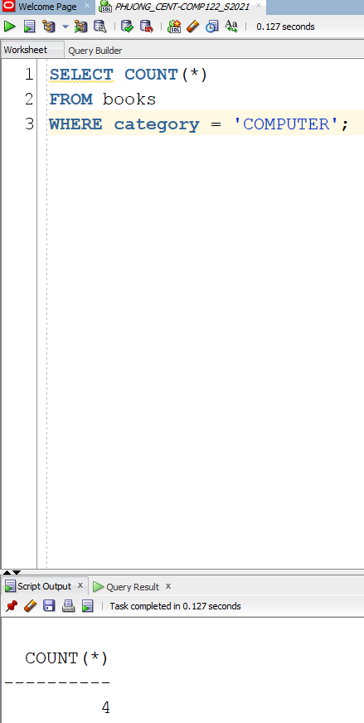SELECT COUNT(*)

FROM books

WHERE category = 'COMPUTER';

3.

SELECT MIN(pubdate)

FROM books;

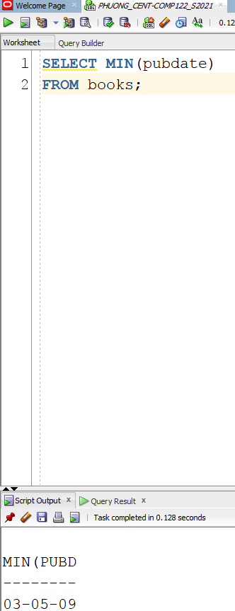

4.

SELECT TO_CHAR(sysdate, 'MM/DD/YYYY:HH24:MI:SS')

FROM dual;

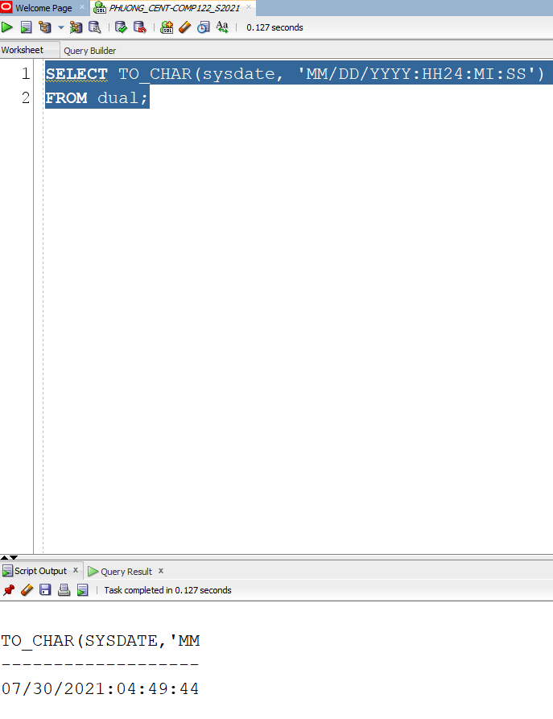

5.

SELECT INITCAP(firstname),INITCAP(lastname)

FROM customers;

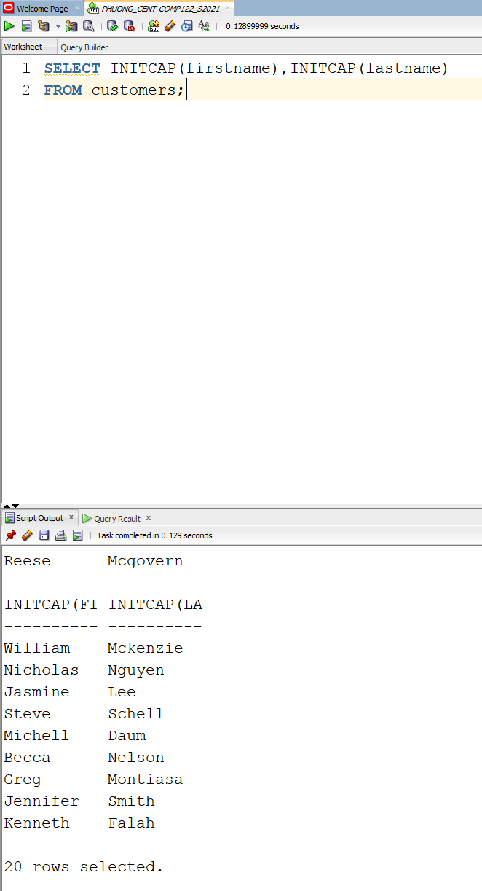

6.

SELECT firstname, lastname,

NVL2(referred, 'REFERRED', 'NOT REFERRED')

FROM customers;

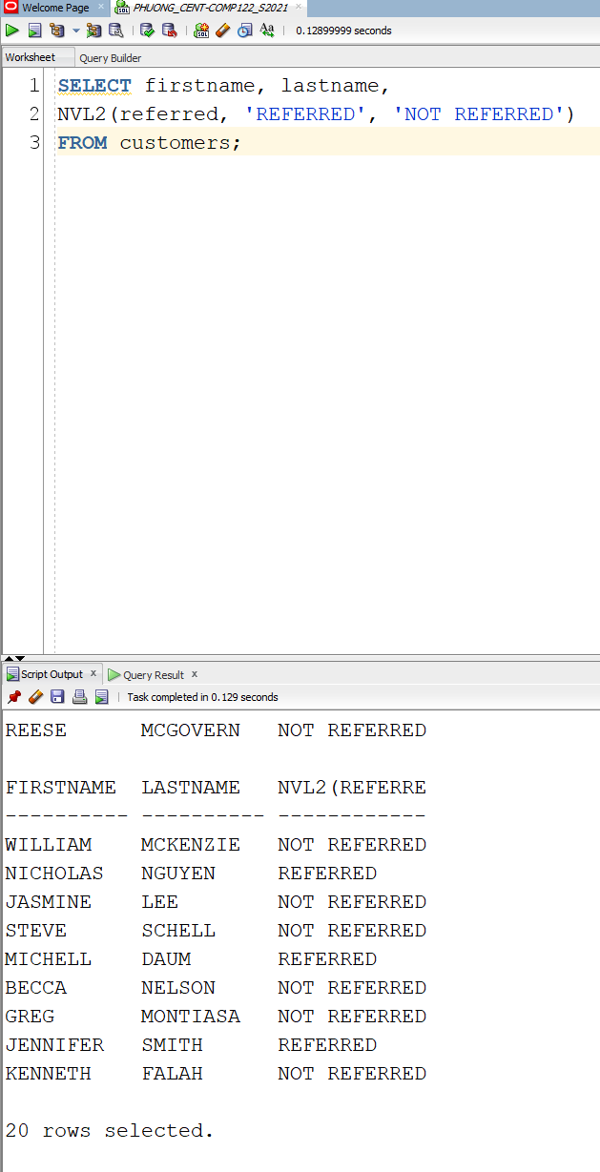

7.

SELECT title, ROUND((retail-cost)/cost*100,0)||'%'

FROM books;

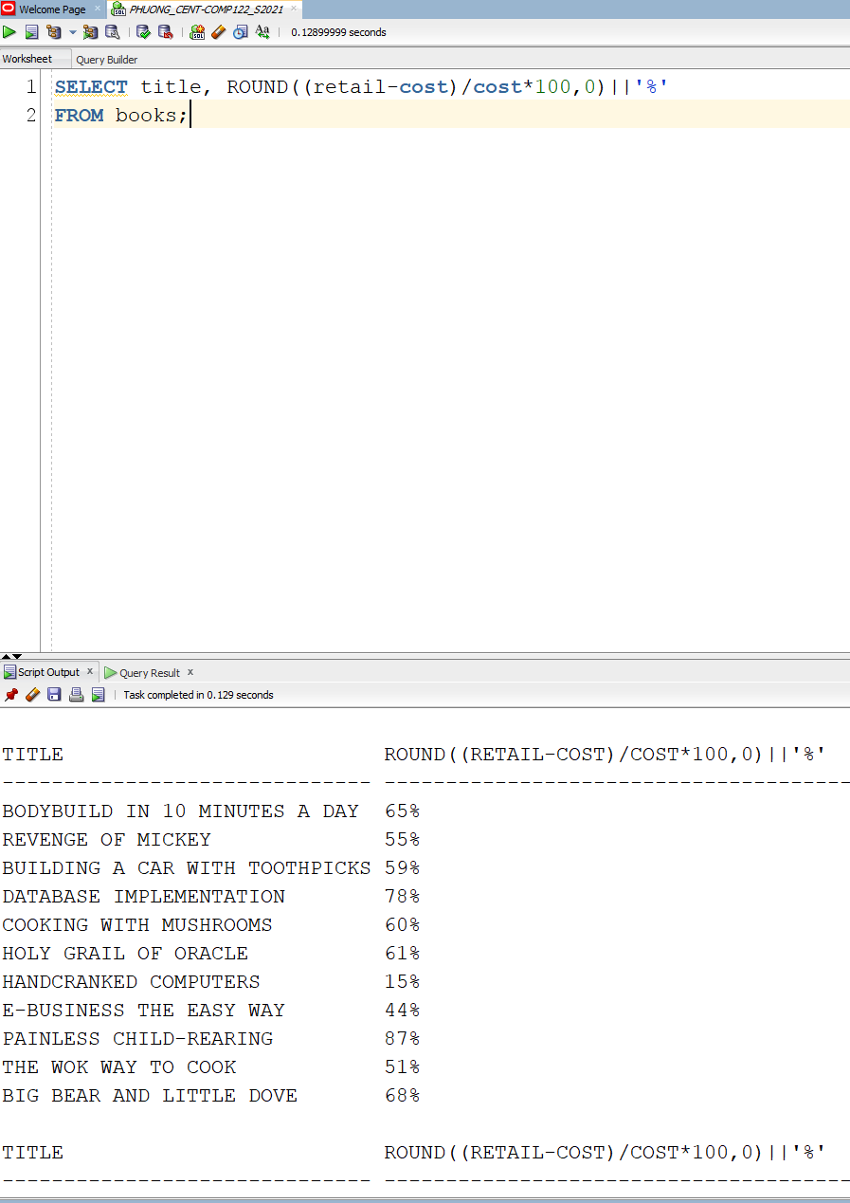

8.

SELECT EMPLOYEES.EMPLOYESS_ID, FIRST_NAME, LAST_NAME,EMPLOYEES.JOB_ID,

SALARY, EMPLOYEES.DEPARTMENT_ID,

CONCAT(ROUND(MONTHS_BETWEEN (TO_DATE(CURRENT_DATE),TO_DATE(START_DATE))), ' Months') AS tenure

FROM EMPLOYEES, JOBS_HISTORY

WHERE

EMPLOYEES.EMPLOYESS_ID = JOBS_HISTORY.EMPLOYESS_ID AND

EMPLOYEES.DEPARTMENT_ID IN(50,70,80,90) AND

SALARY >= 3500 AND

EMPLOYEES.JOB_ID = 'SA_REP';

9.

SELECT LOCATIONS_ID, STREAT_ADDRESS, INSTR(STREAT_ADDRESS, '.')

AS position_number

FROM LOCATIONS;

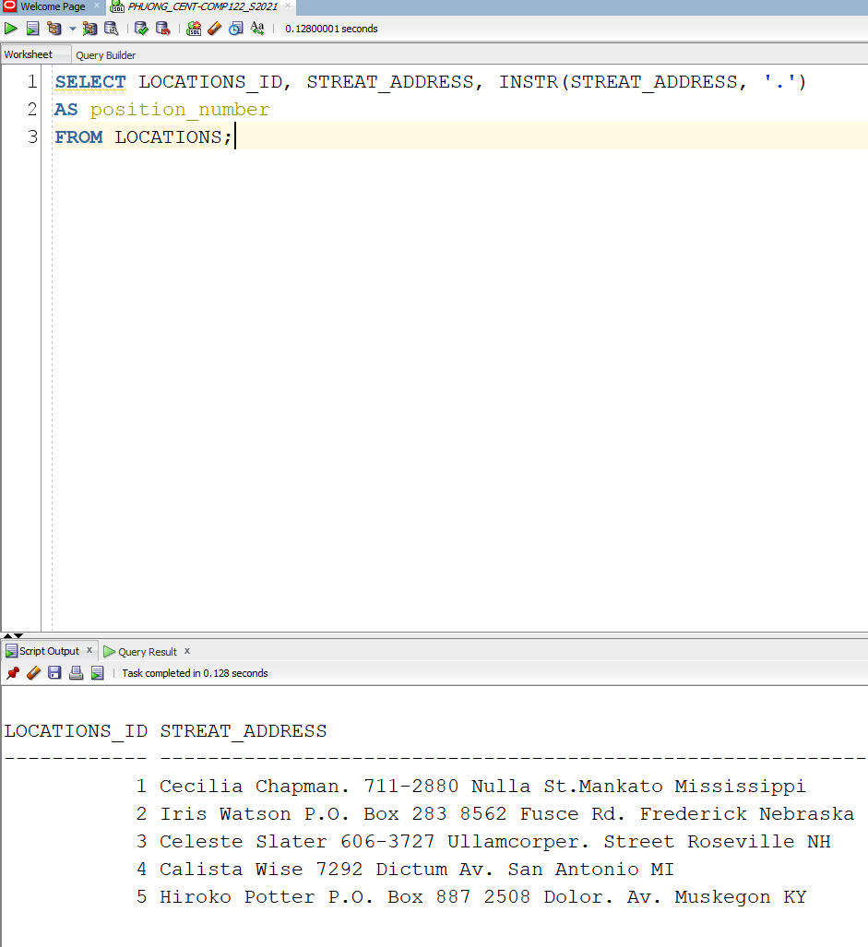

10.

SELECT COUNT(*)

AS PROVINCE_NUM_NULL

FROM LOCATIONS

WHERE STATE_PROVINCE IS NULL;

